***System Design Group Project***

***(Health and Fitness System)***

*Final Project Report*

***Group Members***

*Muhammad Ijlal 14031197*

*Muhammad Mudassir 14031238*

*Faheem Abbas Shah 13031162*

*Muhammad Asad 14031193*

***Monday, March 20, 2017***

# ABSTRACT:-

Inactive and lazy lifestyles are a reason for many chronic diseases. People with less active routines have a greater risk of high blood pressure and heart diseases. In order to integrate physical activities in to people’s lifestyle a number of devices are available in the market including treadmills, cardio exercise bikes and some wearable health management devices. This report states the implementation of a portable device for the use of common people. By using simple hardware the user will be provided with information regarding his heart rate, physical activity and fitness. This portable device enables user to monitor his health and build an active routine to keep himself from diseases caused by inactive lifestyle.

Table of Contents

ABSTRACT:- 1

Introduction 3

Literature review 3

Existing Systems 3

Available Technologies 3

System Requirements 4

Top Level Design 4

Hardware Design 5

Arm Mounted Piece 5

Components Used 5

Circuit Diagram 6

Functionality 6

Foot Mounted Piece 6

Components Used 6

Circuit Diagram 6

Functionality 7

Conclusions 7

Bibliography 7

Appendix 9

# Introduction

Embedded systems have become very common in our daily life routines due to their ability to interact with the world in real time. Portable health and fitness systems are an example of embedded systems step towards a healthy word. Due to the portability, it has become easier than ever to track the health and workout routines and produce effective exercise plans to achieve better health. In this project we are going to provide a similar solution that can help an individual in keeping a track of his health and fitness. The main idea of the project is to design a wearable device which along with the functionalities of displaying current time and date in real time, can also provide health related information. The device should be capable of accurately measuring the heartbeat. It should also be able to provide information regarding the number of steps taken and calories burnt. During the development the product’s design attributes were also kept in considerations so that the interface is user friendly.

# Literature review

## Existing Systems

A number of systems are already present which provide this functionality. “fitbit**”** a health and fitness company has provided many solutions of different types for different users [1]. There products provide quality experience but the prices are quite high for a normal user. Similarly, Under Armour Health box is another quality product which includes a bundle of other features like weight measurement [2]. But same as the former the price is quite high. This device uses chest strap for the measurement of heart rate which has known to impede training activities. Gym watch sensor is another product lying in this category [3]. The device’s price is considerably low compared to the previously mentioned devices but the functionality gets limited to certain indications regarding gym workout only. The aim of our project is to introduce a product for a normal daily life user i.e. build a system keeping an equilibrium between the functionality provided and the cost of the product.

## Available Technologies

To design the product with these functionalities a number of sensors and microcontrollers are required. There are number of options available to perform the required tasks. The heartbeat of a person can be measured from chest, wrist and finger. The pressure sensors and infrared light sensors can be used for this purpose [4] [5]. The option of measuring the heart rate using infrared light from finger proves to be the most effective approach because of its accuracy and ease of use [6]. Similarly, the cadence can be measured using pressure sensors or accelerometer [7]. By performing integration of the values read over a span of time acceleration and then speed and distance can be measured. For communication purposes wired communication, Wi-Fi modules, Bluetooth Modules and NRF radio transmitter modules are the available possibilities. The effective candidates in microcontroller technology are Arduino Primo Core [8], Arduino Uno and Arduino NANO.

# System Requirements

The system requirements includes finding the heart rate and cadence of the user and displaying it in real time on a display. It also involves saving the data and providing the user with graphical reports of his progress. The project could thus be divided in to following parts

1. Displaying current time and date.
2. Measuring and displaying heart rate with an accuracy of ${}_{-}^{+}{1 }$ bpm.
3. Displaying the speed and distance covered with an accuracy of ${}_{ -}^{+}2 \%$.
4. Recording and preparing a graphical report from the data.

# Top Level Design

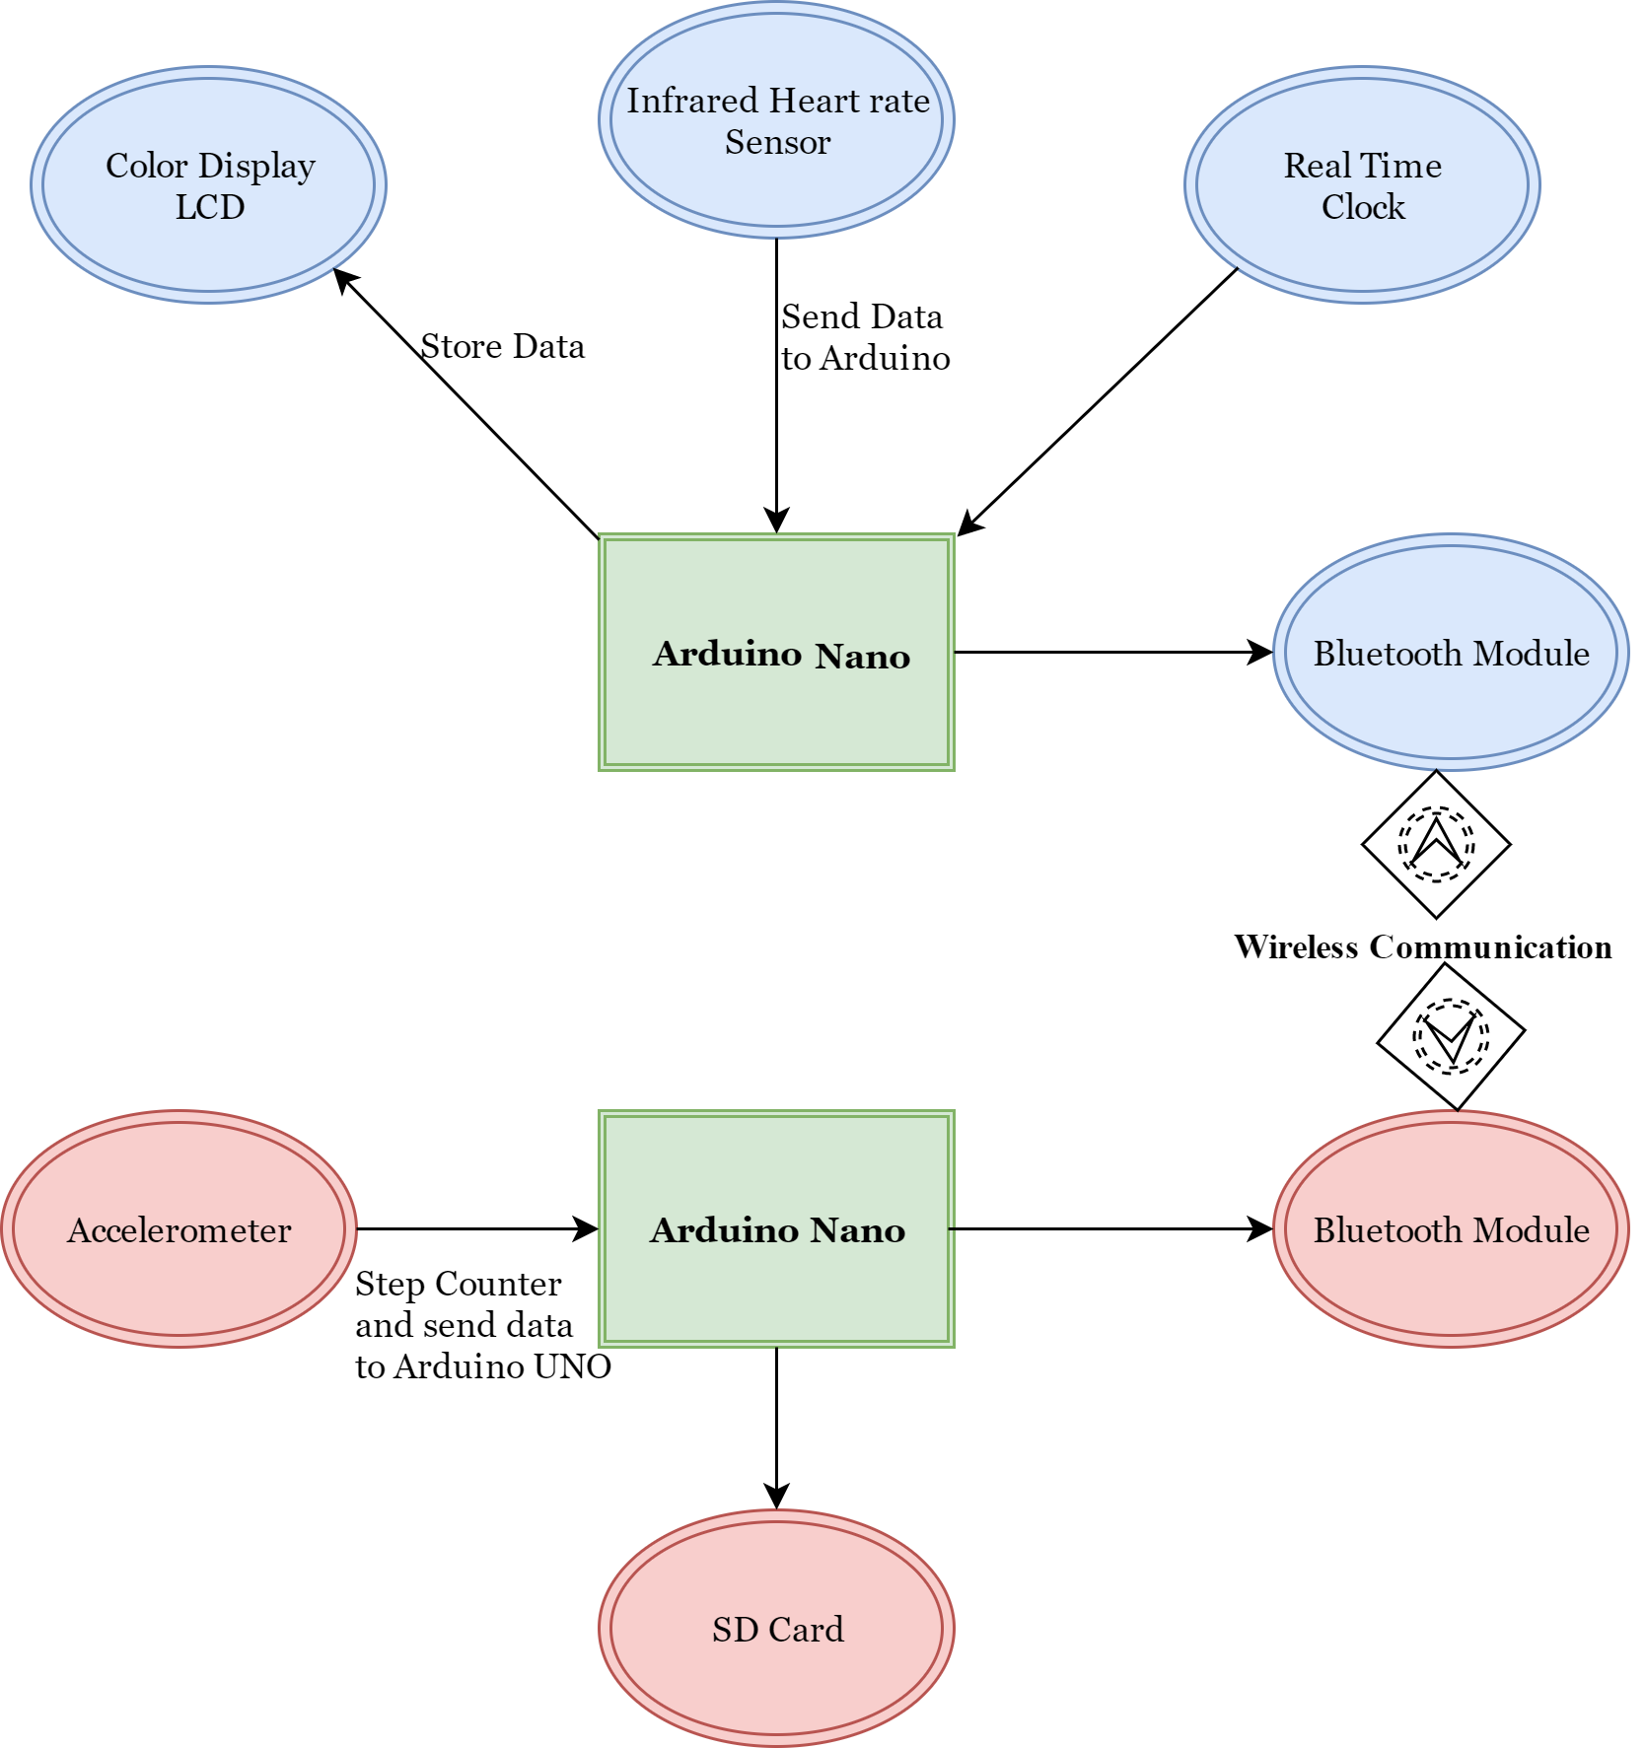

Fig 1 (Block Diagram)

# Hardware Design

The hardware of the system was divided into two parts.

## Arm Mounted Piece

### Components Used

The components used in this part include

1. Arduino NANO
2. Pulse Sensor (SEN-1574)
3. Bluetooth Module (HC-05)
4. 128x128 TFT LCD (ST-7735)
5. RTC

### Circuit Diagram

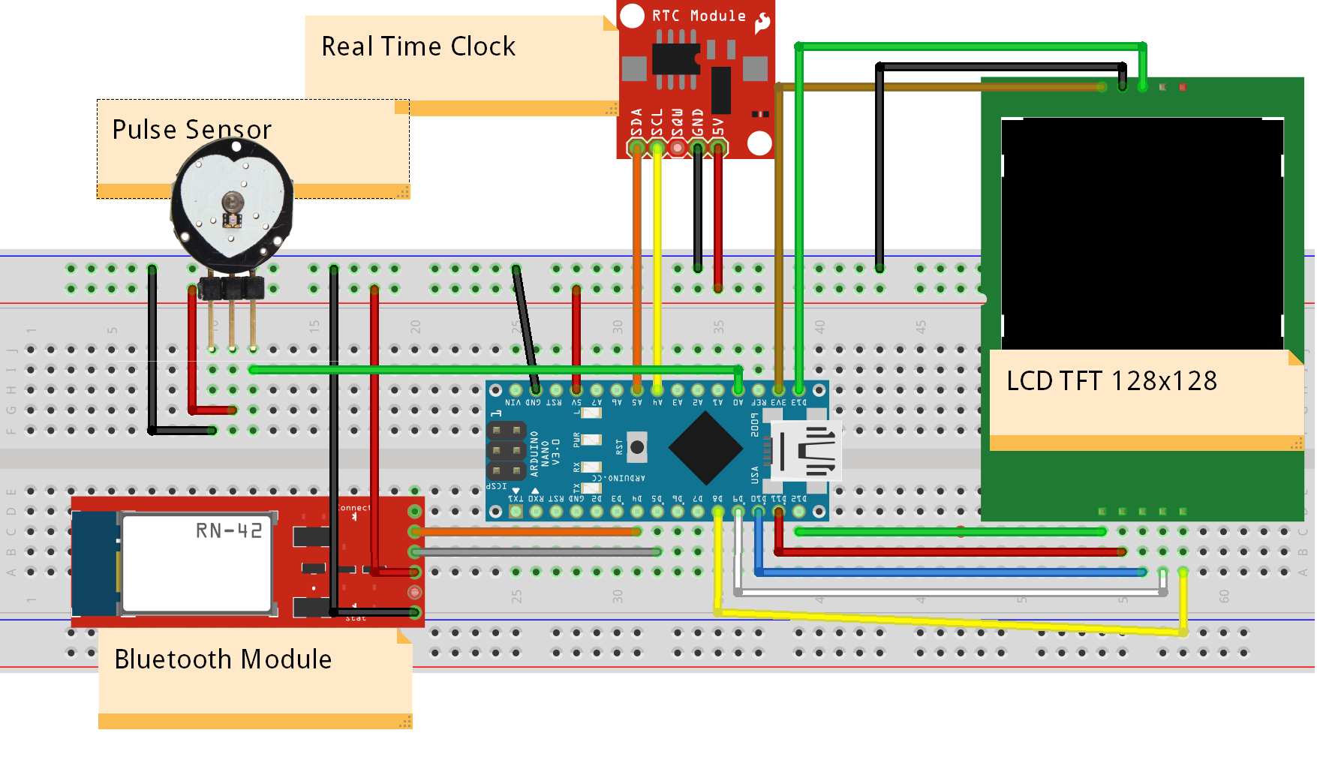

Fig 2 (Arm Mounted Piece)

### Functionality

This part of the hardware had the functionality of measuring Heart Beat using SEN-1754 pulse sensor. RTC is used to keep the device’s time synced with the world clock. The bluetooth module performs communication with the other part of the system. The main display of the system is a 128x128 TFT LCD to show time and other measurements performed.

## Foot Mounted Piece

### Components Used

The components used in this part are

1. Arduino NANO
2. Accelerometer (AXL-335)
3. Bluetooth Module (HC-05)
4. SD Card Module

### Circuit Diagram

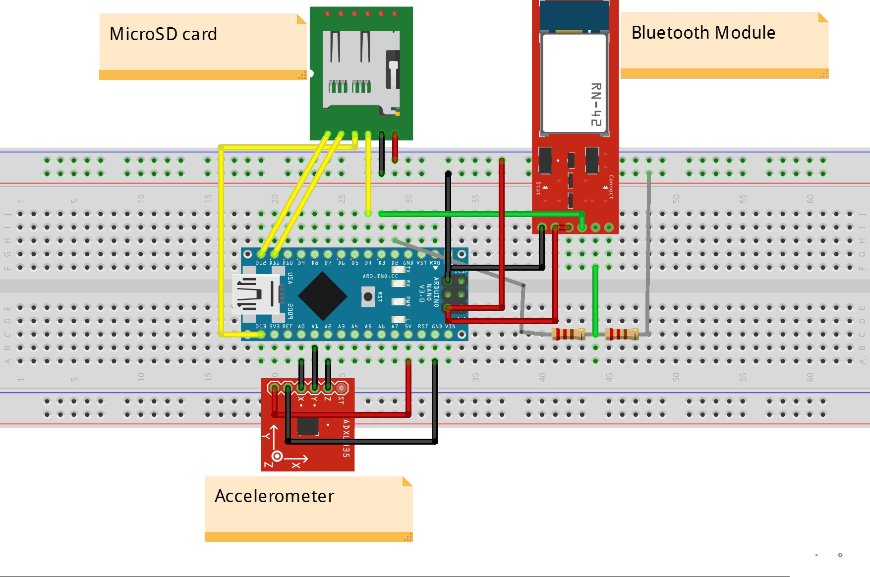

Fig 3 (Foot Mounted Piece)

### Functionality

The major function of the foot mounted piece is to measure speed using accelerometer. Bluetooth module is required to send the measured speed to arm mounted piece for display. Further, the SD Card attached is used to measure the save the measurements performed for later use.

# Software Design

## Maintaining Real Time Clock

Fig 4 (Code Flow for maintaining time)

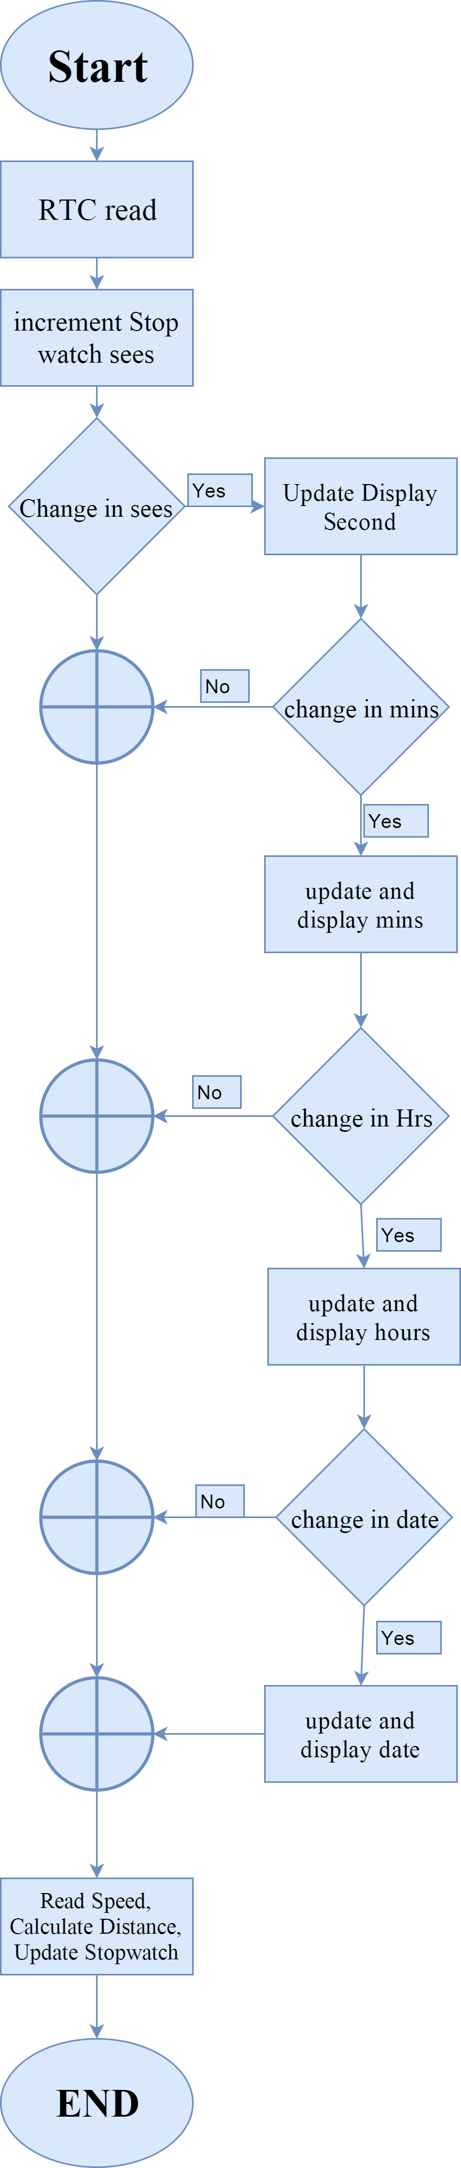

Real time clock was generated using Arduino internal interrupts, an interrupt was generated each second and within the Interrupt service routine the values from RTC were read and update of display was performed. The values of session time, distance covered and speed was updated within the same service routine fig 4.

## Measuring Heart Beat

Using the pulse sensor a set of values after 20ms were read, from a set of 100 values maximum value was detected, and all the values within 98% of the maximum value were declared as peaks. This gave beats per 2 sec. Executed the loop for 50 times and adding the values calculated beats per minutes and displayed it on screen.

## Cadence Measurement

ADXL-335 analog accelerometer was used to measure cadence. Below is the pseudo code for measurement process. A set of 50 values was read and saved in an array. Using integration, area under the curve i.e. speed was measured.

## Storing Data

In order to store data SD.h library was used. Data was communicated between the two parts using bluetooth module HC-05 and software serial library. Speed per second was sent to upper piece for display on LCD whereas heart beat and time was sent to the lower piece for storing in SD card. Separate files for each type of data were created for easy reading.

## Graphical Reports

## Data stored in the SD was read and graphs were generated using the drag and drop GUI features of Matlab. Data was stored in txt files, one value per line. After reading data from the files speed was plotted against session seconds whereas heart beat was plotted against session minutes.

# Working

The foot piece is to worn right above the ankle of any of the two legs, whereas the arm piece is to be worn on the wrist with the pulse sensor on the tip of any finger. On switching on the device a welcome animation and message is displayed. Date and time gets synced and is displayed on the LCD screen. Session time is started and displayed on the bottom of the LCD. The pulse sensor starts reading values, the initial heart beat value being displayed on the screen is kept zero, and after one minute the first value calculated is displayed on the screen. Similarly, when foot piece is switched on, accelerometer starts reading values and sends a value to the arm piece every second which is displayed on the screen. All the calculated values are stored in SD card from where graphs can be generated using the designed GUI. In order to change the values of time, date, weight, and units the arm piece is to be connected to the computer and using the Arduino Serial interface, showing procedure for changing values, instructions are to be followed.

# Results

On completing the project a number of tests were performed to assure proper functioning. The results obtained are added below.

1. A graph of 500 readings taken from heart beat sensor after removing the noisy signals from it.

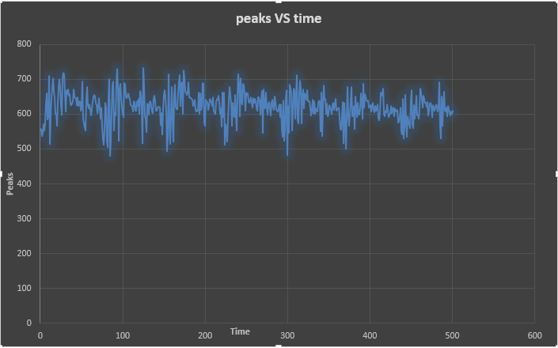

Fig 5 (Heart Beat)

1. Main display showing the measured values.

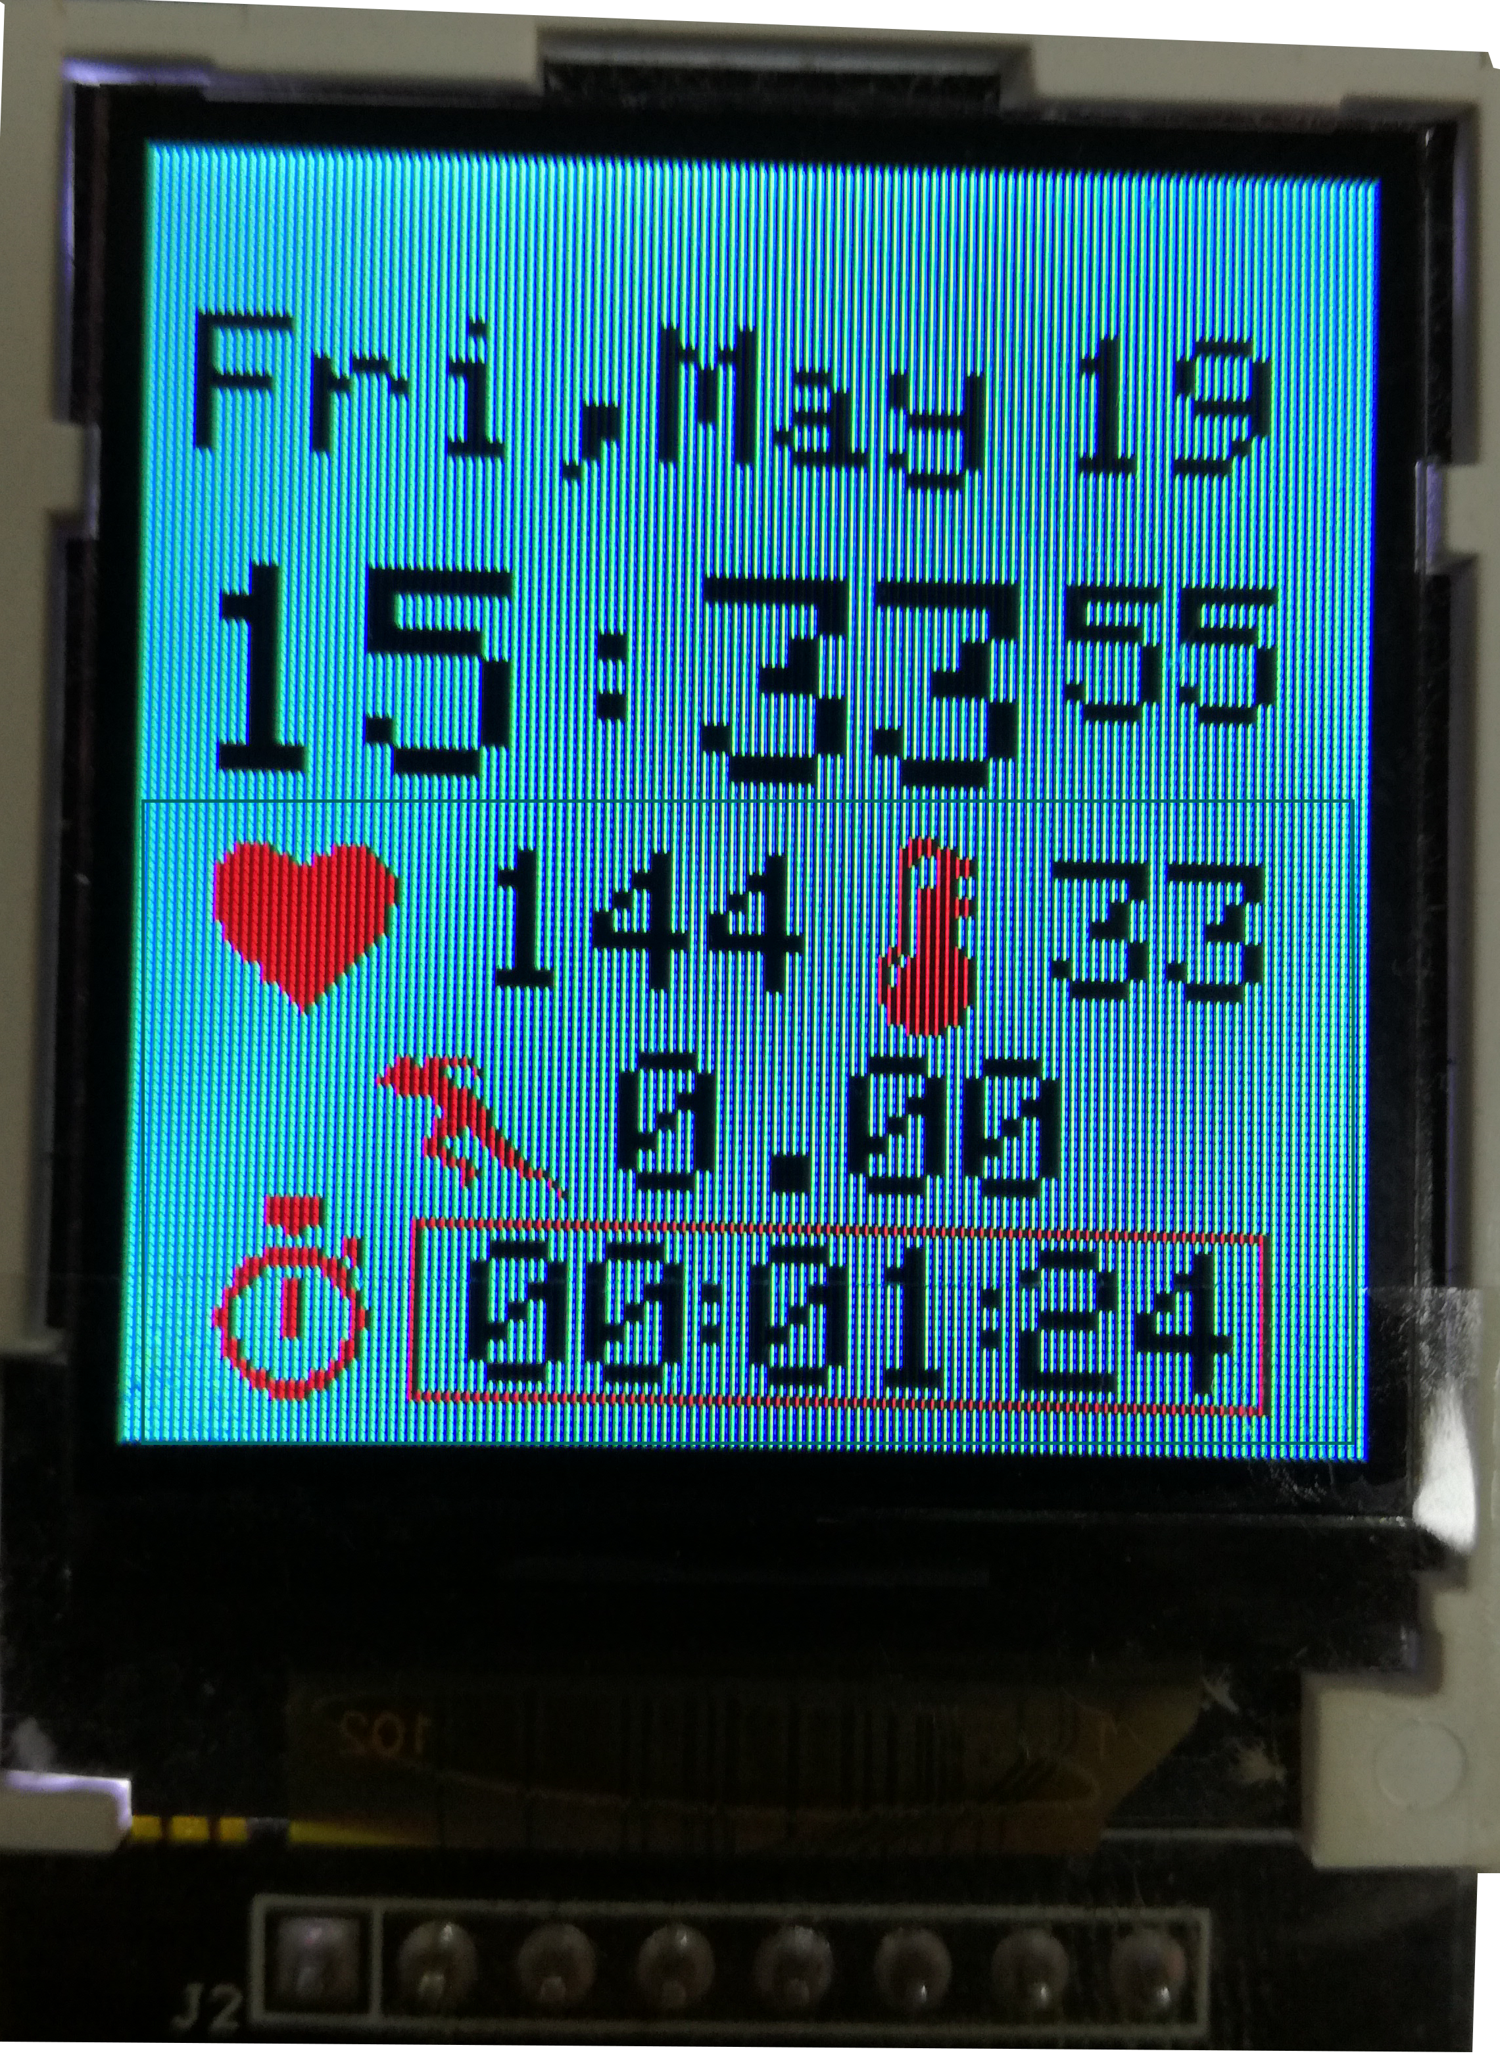

Fig 6 (LCD Display)

1. Speed (m/s) and Heart beat (bpm) graphs.

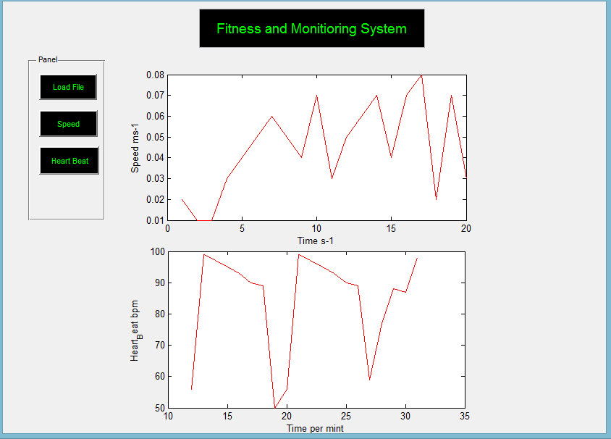

Fig 7 (Speed and Heart Beat Graphs)

# Problems Encountered

During the process a number of problems were encountered, the project used a number of devices and integrating them together had many issues. The main problem faced multiple times was with the communication methods used by different components to communicate with microcontroller. Three of the devices LCD, SD card and NRF modules, were using SPI communication protocol where only one device could be connected a microcontroller. So the NRF module was replaced by Bluetooth modules and SD card was connected to the foot piece but that required two way communication between the two parts. Further, the heart beat sensor was showing huge amount of noise in its readings. In order to remove the noise multiple readings were taken and plotted in Matlab to identify the noise from required values.

# Conclusions

During this project we are gaining the skills of product development. As the project requires to produce a complete product within time and money limitations we are learning various tradeoffs that are to be made at various parts of the project. Along with that, our team work skills are also improving. A lot of collaboration is required while working on different parts of same project which are then to be joined together.

# Bibliography

|  |  |
| --- | --- |
| [1] | I. Fitbit, "fitbit," [Online]. Available: http://www.fitbit.com/home. [Accessed 20 February 2017]. |
| [2] | "Under Armour Healthbox," Under Armour®, Inc., [Online]. Available: https://www.underarmour.com/en-us. [Accessed 20 February 2017]. |
| [3] | Wurzelwerk, "Smart Strenght Traning to Go," GymMatch, [Online]. Available: https://www.gymwatch.com/en/. [Accessed 20 February 2017]. |
| [4] | T. W. K. M. Nicholas Constant, "Pulseband: A Hands-on Tutorial on How to Design a Smart Wristband to Monitor Heart-Rate," ieee.org, 2014. |
| [5] | M. T. I. P. I. A. a. A. R. Nazmus Saquib, "Measurement of Heart Rate Using Photoplethysmography," Department of Computer Science and Engineering Bangladesh University of Engineering and Technology, Dhaka, Bangladesh. |
| [6] | A. K. P. Bandana Mallick, "HEART RATE MONITORING SYSTEM," *International Journal of Science, Engineering and Technology Research (IJSETR),* vol. 5, no. 1, 2016. |
| [7] | K. H. a. T. S. Davrondzhon Gafurov, "Biometric Gait Authentication Using Accelerometer Sensor," *JOURNAL OF COMPUTERS,* vol. 1, no. 7, 2006. |

[8] “Arduino PRIMO CORE.” [Online]. Available: http://www.arduino.org/products/boards/arduino-primo-core. [Accessed: 20-Mar-2017].

# Appendix

Work Breakdown Structure

The whole project was divided according to the following Gant Chart Fig (2). However, we made a little change of integrating both heart beat sensor and accelerometer in parallel.

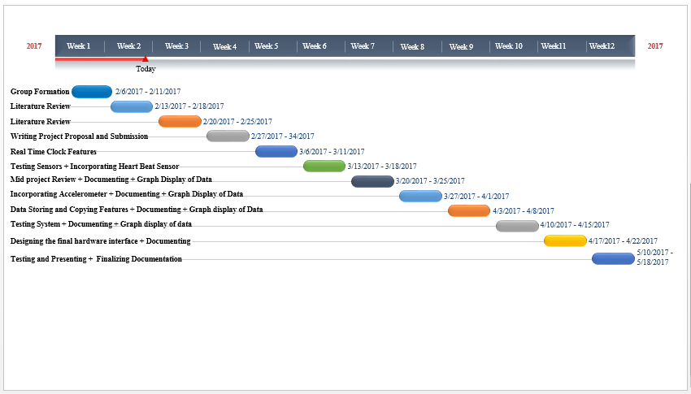

Fig 2 (Gantt Chart)

Group Breakdown Structure

The project is divided among the group members according to the following diagram fig (3).

